Daily report

/* Formatted on 7/30/2013 3:32:03 PM (QP5 v5.139.911.3011) */

SELECT DECODE ( GROUPING ( v.vehicle_type ), 1, 'Grand Total', v.vehicle_type ) vehicle_type

, DECODE ( GROUPING ( v.vehicle_desc ), 1, 'Total by Class', v.vehicle_desc ) vehicle_desc

, SUM ( f.fct_quantity ) quantity

, ROUND ( SUM ( f.fct_amount ) ) amount_sold

-- , GROUPING ( v.vehicle_type )

-- , GROUPING ( v.vehicle_desc )

FROM tmp_vehicles v

JOIN tmp_transactions f

ON v.vehicle_id = f.vehicle_id

JOIN tmp_dealers d

ON d.dealer_id = f.dealer_id

WHERE d.dealer_country = 'Germany'

AND TRUNC ( TO_DATE ( event_dt )

, 'DDD' ) = TO_DATE ( '12-jan-2010'

, 'dd-mon-yyyy' )

GROUP BY CUBE ( v.vehicle_type, v.vehicle_desc )

HAVING GROUPING_ID ( v.vehicle_type

, v.vehicle_desc ) IN (0, 1, 3);

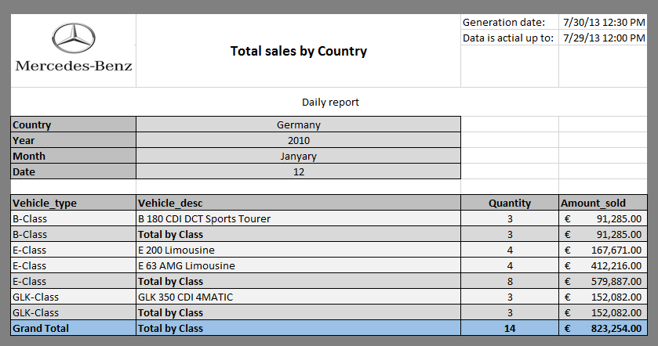

Monthly report

/* Formatted on 7/30/2013 3:20:35 PM (QP5 v5.139.911.3011) */

SELECT DECODE ( GROUPING ( v.vehicle_type ), 1, 'Grand Total', v.vehicle_type ) vehicle_type

, DECODE ( GROUPING ( v.vehicle_desc ), 1, 'Total by Class', v.vehicle_desc ) vehicle_desc

, SUM ( f.fct_quantity ) quantity

, ROUND ( SUM ( f.fct_amount ) ) amount_sold

, GROUPING ( v.vehicle_type )

, GROUPING ( v.vehicle_desc )

FROM tmp_vehicles v

JOIN tmp_transactions f

ON v.vehicle_id = f.vehicle_id

JOIN tmp_dealers d

ON d.dealer_id = f.dealer_id

WHERE d.dealer_country = 'Germany'

AND f.event_dt >= TRUNC ( TO_DATE ( '01-jan-2013'

, 'dd-mon-yyyy' )

, 'month' )

AND f.event_dt <= (TRUNC ( TO_DATE ( ADD_MONTHS ( TO_DATE ( '01-jan-2013'

, 'dd-mon-yyyy' )

, 1 ) )

, 'month' )

- 1)

GROUP BY ROLLUP ( v.vehicle_type, v.vehicle_desc )

;

